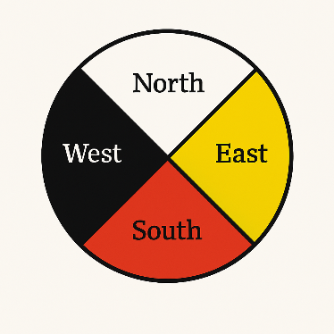
Medicine Wheel Directions Activity (Kindergarten)
This printable pack includes:
- Coloring template of the Medicine Wheel with directions
- Movement direction cards for group activity
- Teacher instructions

Teacher Instructions
- Begin by showing students a large Medicine Wheel and introducing the four directions: North (White), East (Yellow), South (Red), West (Black).
- White is for the North, like snow
- Yellow is for the East, where the sun comes up
- Red is for the South, warm and full of life
- Black is for the West, night time

- Use the included coloring sheet to help students label and color each direction.

- Make direction movement cards to call out a direction (north, east, south and west) — students move to that area. (provide below)

- Add a movement or sound for each direction to reinforce learning. - North: Freeze like snow - East: Stretch like the sun rising - South: Wiggle or dance - West: Close eyes and take a breath like nighttime. (playing music will add fun, and stopping music will be the cue for students to move to the specified direction)

- Reflect together by asking questions: 'Which direction do you like best?' or 'What color is the West?'

Color the Directions of the Medicine Wheel
- North (White)
- West (Black)
- South (Red)
- East (Yellow)

Movement Activity
Place the directions cards around the room, or outdoors, and show the students where each direction is located. When students know the direction they are to go to, show them the movement they are to do when they get to that spot.
- Go to the North! Freeze like snow
- Go to the East! Stretch like the rising sun
- Go to the South! Wiggle or dance
- Go to the West! Close your eyes and breathe

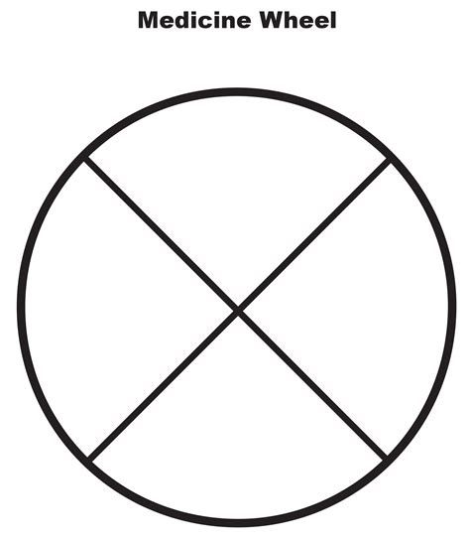

North

South

East

West

Go to the North!
Freeze like snow

Go to the East!

Stretch like the rising sun

Go to the South!

Wiggle or dance

Go to the West!

Close your eyes and breathe

